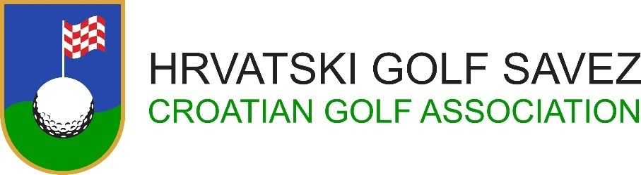

CROATIA MIDAM OPEN 2022


Riverside Golf Zagreb
1ST – 3RD July 2022

ENTRY FORM

Nationality:
Last Name:
First Name:
Gender:
Date of Birth:
(DD/MM/YEAR)
City:
Phone:
Email:
Home Club:
Handicap:
(+ = below 0)
Date:
(DD/MM/YEAR)
Signature of Applicant:
Handicap and Amateur Status of the above player are hereby confirmed by golf federation / association:
Date
(DD/MM/YEAR)
Croatian Golf Association must receive fully completed Entry Form
Until Friday, June 28th 2022, no later than 12:00 o’clock
Entry Form must be delivered by e‐mail: ured@golfsavez.hr

