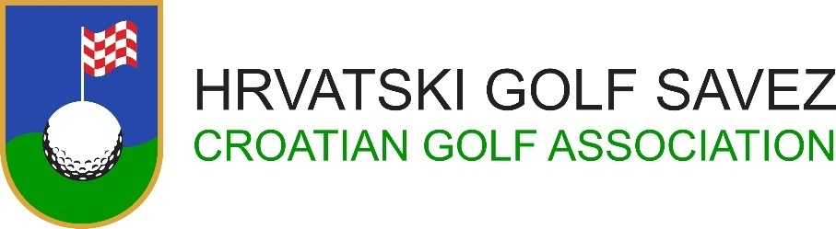

CROATIA OPEN 2022
30th Croatian International Amateur Championship


Riverside Golf Zagreb
9th – 12th June 2022

ENTRY FORM

Nationality:
Last Name:
First Name:
Gender:
Date of Birth:
(DD/MM/YEAR)
Gsm for contact:
Email:
Home Club:
Handicap:
(+ = below 0)
Date:
(DD/MM/YEAR)
Signature of Applicant:
Handicap and Amateur Status of the above player are hereby confirmed by golf federation / association:
Date
(DD/MM/YEAR)
Croatian Golf Association must receive fully completed Entry Form
until Friday, June 6th 2022, no later than 12:00 o’clock
Entry Form please send on: ured@golfsavez.hr

